Wrongful Convictions: Causes and Remedies
Douglas County Bar Association
December 2016

Alice Craig
Supervising Attorney
Paul E. Wilson Project for Innocence
and Post-conviction Remedies
University of Kansas School of Law
1535 W.15th Street
Lawrence, Kansas 66045
alice.craig@ku.edu
Materials developed with Elizabeth Cateforis, Clinical Professor

The Project for Innocence at the University of Kansas School of Law was established in 1965, in order to provide legal services to the indigent inmates in Kansas. Over time, this core mission has not changed, but due to changes in the law, especially the implementation of both federal and state filing deadlines, the kinds of cases we take has changed. Although we have always worked on innocence cases, our primary focus has been traditional post-conviction litigation in cases with claims of ineffective assistance of counsel and claims of due process violations based on prosecutorial misconduct. The biggest barrier in working innocence cases has been money. Expert testimony and forensic testing are not free.
Enter the Midwest Innocence Project, a 501(c)(3) corporation that is dedicated to the investigation, litigation and exoneration of wrongfully convicted men and women in a 5-state region, Missouri, Kansas, Arkansas, Iowa, and Nebraska. In the Fall of 2014, MIP and the Project for Innocence entered into a formal relationship. The Project will work on Kansas innocence cases and other states’ cases, if resources and time allow, and MIP will provide funding for necessary investigation, testing, and litigation.
Various studies, government and private, estimate that between 2% and 8% of inmates incarcerated in America were wrongfully convicted. The current population incarcerated in American prisons is 1.5 million persons.

Limitations of “traditional” post-conviction litigation:

Life of a criminal case
(3) United States Supreme Court (Discretionary) | (6) United States Supreme Court (Discretionary) | (9) United States Supreme Court (Discretionary)
(2) KS Sup. Ct.  (Discretionary)  -------------  KS Court of Appeals | (5) KS Sup. Ct.  (Discretionary)  -------------  KS Court of Appeals | (8) 10th Circuit Court of Appeals
(1) Trial Court | (4) Trial Court | (7) Federal District Court
Direct Appeal  Issues presented at trial and preserved by trial counsel | State Post Conviction/ State Habeas  New issues that could not have been presented previously | Federal Habeas  Federal issues preserved through both Direct Appeal and Post conviction process

Time Limits:
Habeas:
Kansas: K.S.A. 60-1507: One year from the date conviction is final.
Federal: 28 U.S.C. sec. 2254: One year from the date conviction is final plus 90 days in which certiorari could be filed. There is an “exception” for actual innocence.
Newly Discovered Evidence:
Depends on the State: Kansas – two years.
Average time for exoneration: over 10 years.
Issues on habeas:
Ultimately, the issues that the courts consider are procedural, with substantive effects. But petitioners generally cannot raise the substantive issue of innocence, without an underlying legal claim.
Identifying the Causes of Wrongful Convictions

DNA exonerations provide a window into wrongful convictions.
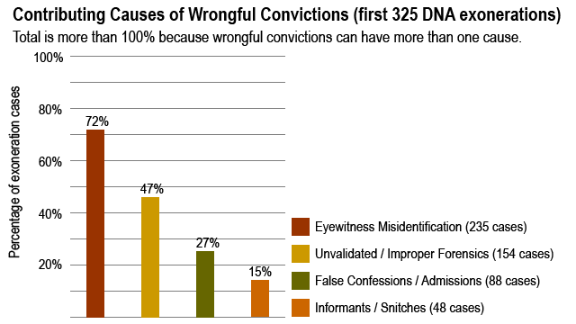

Here’s a broader look. Over time, the National Registry has determined there have been 1493 exonerations as of year end 2014. The registry now list 1820 exonerations.
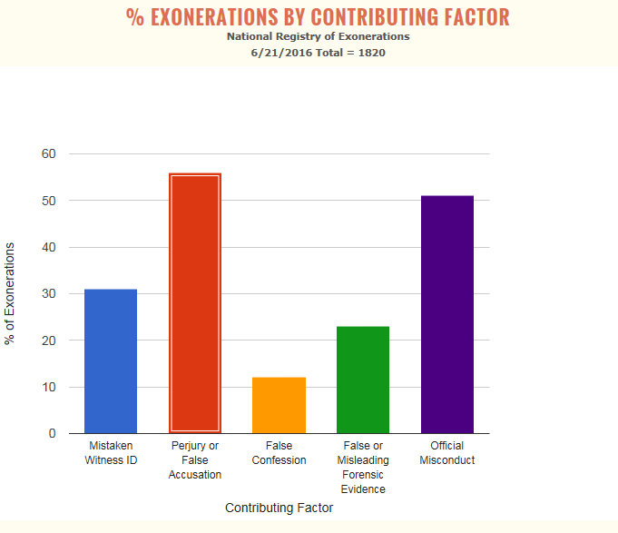
From The Cardozo Innocence Project
Mistaken Identification: When Witnesses Get It Wrong
In case after case, DNA has proven that eyewitness identification is frequently inaccurate. In the wrongful convictions where eyewitness misidentification played a role, the circumstances varied substantially. For example, the Innocence Project has worked on cases in which:
A witness made an identification in a “show-up” procedure (where witnesses are shown only the suspect at the scene of the crime or in another incriminating context) from the back of a police car hundreds of feet away from the suspect in a poorly lit parking lot in the middle of the night. A witness in a rape case was shown a photo array where only the photo of the person that the police suspected was marked with an “R”, while the rest were unmarked Witnesses substantially changed their description of a perpetrator (including key information such as height, weight and presence of facial hair) after they learned more about a particular suspect. Witnesses only made an identification after multiple photo arrays or lineups — and then made hesitant identifications (saying they “thought” the person “might be” the perpetrator, for example) – but at trial the jury was told the witnesses did not waver in identifying the suspect.

Decades of Solid Scientific Evidence Supports Reform
In October of 2014, the National Academy of Sciences (NAS), the nation's premier scientific entity, issued a groundbreaking report settling many long-debated areas of police practice. The report identified a set of reform procedures, which have been promoted by the Innocence Project since the inception of its work in this area of police practice.
In 1907, Hugo Munsterberg published On the Witness Stand, in which he questioned the reliability of eyewitness identification. When Yale Law professor Edwin Borchard studied 65 wrongful convictions for his pioneering 1932 book, Convicting the Innocent, he found that eyewitness misidentification was the leading contributing factor of wrongful convictions.

Research illustrates that the human mind is not like a tape recorder; we neither record events exactly as we see them, nor recall them like a tape that has been rewound. In eyewitness identifications, witness memory is impacted by a variety of factors that occur from the time of the crime onwards, and their memories can be easily contaminated.
Hundreds of scientific studies (particularly in the last three decades) have affirmed that eyewitness identification is often inaccurate and that it can be made more accurate by implementing specific identification reforms.

Reforms and Solutions
Several easy-to-adopt procedures have been shown to significantly decrease the number of misidentifications. In order to prevent additional wrongful convictions due to misidentification, the Innocence Project is collaborating with law enforcement and policymakers to adopt the following policies:
Blind/Blinded administration
Blind administration, where the officer administering the lineup is unaware of who the suspect is, can prevent suggestive statements or unconscious gestures or vocal cues that may influence the witness, thereby reducing the risk of a misidentification. For the small police agency with work force constraints, a method called the "folder shuffle" can be utilized to effectively blind the administrator. Lineup composition
“Fillers” (the non-suspects included in a lineup) should resemble the eyewitness’ description of the perpetrator. Further, the suspect should look similar to the fillers (for example, he should not be the only member of his race in the lineup, or the only one with facial hair). Eyewitnesses should also not view more than one identification procedure with the same suspect. Instructions:
The person viewing the lineup should be told that the perpetrator may or may not be in the lineup and that the investigation will continue regardless of the lineup result. This reduces the pressure on the witness of feeling like they have to pick a perpetrator. The witness should also be told not to look to the administrator for guidance. Confidence Statements:
Law enforcement should elicit and document a statement from an eyewitness articulating his or her level of confidence in the identification made at the time that the identification is made. Recording: Identification procedures should be videotaped and/or audiotaped whenever possible.
Fourteen states have implemented these reforms through laws, court action and policy directives, while jurisdictions including Baltimore, Boston, Dallas, Minneapolis, Oklahoma City, Philadelphia, San Diego, San Francisco and Tucson have made eyewitness identification reform procedures part of their standard practice.
- See more at: http://www.innocenceproject.org/causes-wrongful-conviction/eyewitness-misidentification#sthash.jkFGo5WU.dpuf
KANSAS:
In 2016, the Kansas legislature passed, SB 428, which requires police to adopt written policies on eyewitness identification procedures and recommends that those policies include: 1) the blind administration of lineups, in which the administering officer is not aware of the suspect; 2) instructions for the eyewitness that the perpetrator may or may not be in the lineup; 3) fair lineup composition in which all members of a lineup resemble the description provided by the witness and 4) confidence statements by the eyewitness regarding their level of confidence in their identification. These practices are endorsed by the National Academy of Sciences, the International Association of Chief of Police and many others.
In State v. Reginald Carr, 300 Kan. 1 (2014), the Kansas Supreme Court abrogated its prior cases banning the introduction of expert testimony about the problems with eyewitness identifications, memory, and identification procedures . Admission can now be considered on a case by case basis.

Also from The Cardozo Innocence Project
Why do innocent people confess?
The reasons that people falsely confess are complex and varied, but what they tend to have in common is a belief that complying with the police by saying that they committed the crime in question will be more beneficial than continuing to maintain their innocence.
The factors that can contribute to a false confession during a police interrogation include:
Duress, coercion, intoxication, diminished capacity, mental impairment, ignorance of the law, fear of violence, the actual infliction of harm, the threat of a harsh sentence, misunderstanding the situation.
Confessions obtained from juveniles are often unreliable -- children can be easy to manipulate and are not always fully aware of their situation.
People with mental disabilities have often falsely confessed because they are tempted to accommodate and agree with authority figures. Many law enforcement interrogators are not given special training on questioning suspects with mental disabilities. An impaired mental state due to mental illness, drugs or alcohol may also elicit false admissions of guilt.
Mentally capable adults also give false confessions due to a variety of factors like the length of interrogation, exhaustion or a belief that they can be released after confessing and prove their innocence later.
From threats to torture
Sometimes, law enforcement use harsh interrogation tactics with uncooperative suspects. But some police officers, convinced of a suspect’s guilt, occasionally use tactics so persuasive that an innocent person feels compelled to confess. For instance, it is perfectly legal for law enforcement to employ deception or trickery in the interrogation room. Some suspects are untruthfully told that there is already evidence pointing to their guilt, such as a forensic test that links the suspect to the crime. Some suspects have confessed to avoid physical harm or discomfort. Others are told they will be convicted with or without a confession and that their sentence will be more lenient if they confess. Some are told a confession is the only way to avoid the death penalty. These tactics can be persuasive in eliciting a false confession.
Reforms and Solutions
Mandatory Recording of Interrogations
The electronic recording of interrogations, from beginning to end, is the single best reform available to prevent wrongful convictions caused by false confessions. This record will improve the credibility and reliability of authentic confessions, while protecting the rights of innocent suspects.
In some false confession cases, details of the crime are inadvertently communicated to a suspect by police during questioning. Later, when a suspect knows these details, the police take the knowledge as evidence of guilt. Often, threats or promises are made to the suspect off camera and then the camera is turned on, resulting in a false confession. Without an objective record of the entire custodial interrogation, it is difficult to gauge the reliability of the confession.
For law enforcement agencies, recording interrogations can prevent disputes about how a suspect was treated, create a clear record of a suspect’s statements and increase public confidence in the criminal justice system. Recording interrogations can also deter officers from using illegal or devious tactics to secure a confession.
During the 2016 Kansas Legislative Session, HB2593 on mandatory recording of custodial interrogations was introduced but died in committee. The language of the bill is:

Session of 2016

HOUSE BILL No. 2593

By Committee on Corrections and Juvenile Justice 2-2

- AN ACT concerning crimes, punishment and criminal procedure; relating
- to evidence; videotaping of certain felony interrogations. 3
- Be it enacted by the Legislature of the State of Kansas:
- Section 1. (a) As used in this section:
- (1) "Custodial interrogation" means questioning or other conduct by a
- law enforcement officer which is reasonably likely to elicit an
- incriminating response from an individual and occurs when reasonable
- individuals in the same circumstances would consider themselves in
- custody.
- (2) "Place of detention" means a fixed location under the control of a
- law enforcement agency where individuals are questioned about an alleged
- crime or offense, including, but not limited to, a police or sheriff's station,
- a courthouse holding facility for defendants in the custody of a jail or
- prison, a city or county jail or work release facility, a state prison or a state
- security hospital or a facility operated by the department for aging and
- disability services for the purposes provided for under K.S.A. 59-29a02 et
- seq., and amendments thereto.
- (3) "Video recording" means an audio and video recording that
- accurately records a custodial interrogation.
- (b) (1) Except as provided in subsection (c), a video recording shall
- be made of a custodial interrogation conducted in any place of detention
- when the interrogation concerns a capital murder, as defined in K.S.A.
- 2015 Supp. 21-5401, and amendments thereto, murder in the first degree,
- as defined in K.S.A. 2015 Supp. 21-5402, and amendments thereto,
- murder in the second degree, as defined in K.S.A. 2015 Supp. 21-5403,
- and amendments thereto, or rape, as defined in K.S.A. 2015 Supp. 21-
- 5503, and amendments thereto. The recording shall include the giving of
- any required warning, advice of the rights of the individual being
- questioned and the waiver of any rights by the individual. If the defendant
- elects to make or sign a written statement during the course of a custodial
- interrogation, the making and signing of the writing shall be recorded. The
- recording shall not end until the interrogation is concluded.
- (c) A video recording of a statement under subsection (b) is not
- required if the oral, written or sign language statement was made:
- (1) During an interrogation that was not recorded as required by

HB 2593 2

- subsection (b) because video recording was not feasible;
- (2) spontaneously and not in response to a question;
- (3) voluntarily, whether or not the result of an interrogation, and the
- statement has a bearing on the credibility of the accused as a witness;
- (4) after questions which are routinely asked during the processing of
- the arrest of a suspect;
- (5) in an interrogation outside the state of Kansas;
- (6) at a time when the interrogators are unaware that an offense
- covered by subsection (b) has occurred; or
- (7) at a time when the person being interrogated is not a suspect for
- the offense to which the statement relates while the person is being
- interrogated for an offense other than an offense specified in subsection 13 (b).
- (d) If the court finds by a preponderance of the evidence that the
- defendant was subjected to an interrogation in violation of this section, the
- defendant shall be entitled to a jury instruction on the failure to record the
- interrogation. If the defendant requests such an instruction, the court shall
- instruct the jury that it is the law of Kansas to make a video recording of a
- custodial interrogation of a person suspected of committing the offense
- charged.
- (e) Every video recording required under this section shall be
- preserved until the defendant's conviction for an offense relating to the
- statement is final and all direct appeals are exhausted, or until the
- prosecution of offenses related to the recorded statement is barred by law,
- whichever occurs later.
- (f) Every video recording of any statement as required by this section
- shall be confidential and exempt from the Kansas open records act in
- accordance with K.S.A. 45-221, and amendments thereto. The provisions
- of this subsection shall expire on July 1, 2021, unless the legislature
- reviews and reenacts this provision pursuant to K.S.A. 45-229, and
- amendments thereto, prior to July 1, 2021.
- Sec. 2. This act shall take effect and be in force from and after its
- publication in the statute book.

Proven Success
More than 20 states, from North Carolina to Massachusetts to Illinois, require the recording of custodial interrogations through law or court action. More than a thousand additional law enforcement agencies voluntarily record interrogations. A 2004 study conducted by the Center on Wrongful Convictions of more than 200 locations that implemented this reform found that police departments overwhelmingly embrace the measure as good law enforcement practice whose time has come. Proactive policies like these have been adopted because the practice benefits police and prosecutors as well as innocent suspects.
- See more at: http://www.innocenceproject.org/causes-wrongful-conviction/false-confessions-or-admissions#sthash.sUNK6Csz.dpuf

Forensic “Science”
If you have watched any recent crime show, NCIS and Bones, you have seen forensic science in action.
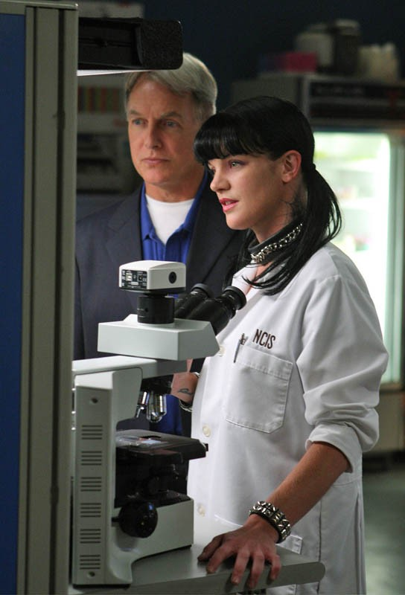

However, real life is not quite so tidy or scientific. Much of the science that has been relied on for convictions is not science at all.
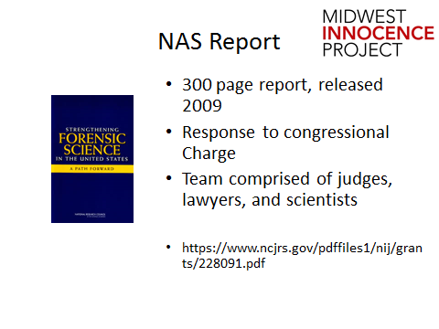

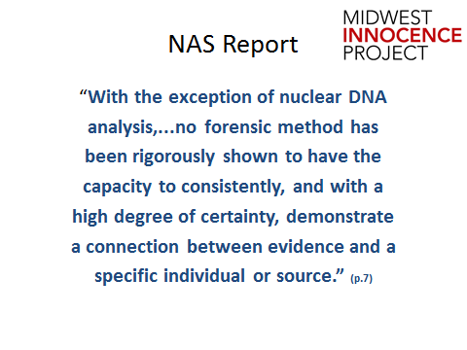

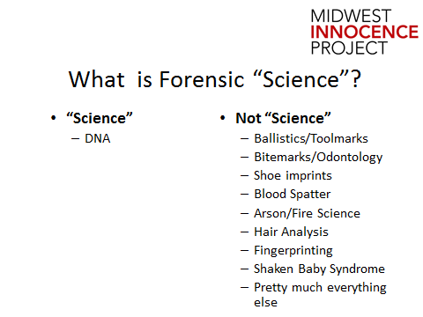
- NAS Report: Major points on pattern evidence:
  - Only nuclear DNA analysis has been rigorously shown to have the capacity to consistently individualize trace evidence
  - Inconsistencies and disparities among existing forensic science operations
  - No uniform certification of forensic practitioners
  - A “serious problem”: Interpretation of forensic evidence is not always based on studies of its validity
  - More research is needed to establish the limits of forensic science
- NAS Report’s admissibility questions:
  - Is the forensic discipline founded on a reliable scientific methodology?
  - Are the practitioners relying on human interpretation that could be:
    - Tainted by error
    - Biased
    - Not grounded in sound practices
    - Not subjected to robust performance standards
- Daubert factors:
  - Can be or has been tested (it hasn’t)
  - Peer review and publication (examiners)
  - The known or potential error rate (not known)
  - Standards controlling the operation of the theory or technique (there are none)
  - Widespread acceptance within a relevant scientific community (what is the “relevant” scientific community?)
- Frye: “novel” techniques “generally accepted by the relevant scientific community”
For every conviction based on forensic science, there is an exoneration showing an error in the science. The NAS report places only DNA is the category of actual science. But, DNA is only as infallible as its weakest human link. Time and time again, our justice system has seen scandals where crime labs have falsified DNA evidence to “assist” the government in gaining a conviction. Cognitive bias plays a significant role in the reliability of crime lab examiners. Systematic changes are needed to ensure our convictions are based on truly accurate information.
On top of the lack of “science” underlying the results of forensic testing the language used by examiners in court is troubling. There is a significant correlation between the jury’s interpretation of the forensic evidence and the language of certainty used by examiners. The language often implies a level of scientific certainty that should not be provided to any of the forensic “science” disciplines.
The next page illustrates language often used by forensic examiners in court and the problems with such testimony. In June 2016, the FBI released a Proposed Uniform Language For Testimony And Reports For The Forensic Toxicology Discipline. This language is also included. This proposal is currently in a comment period.

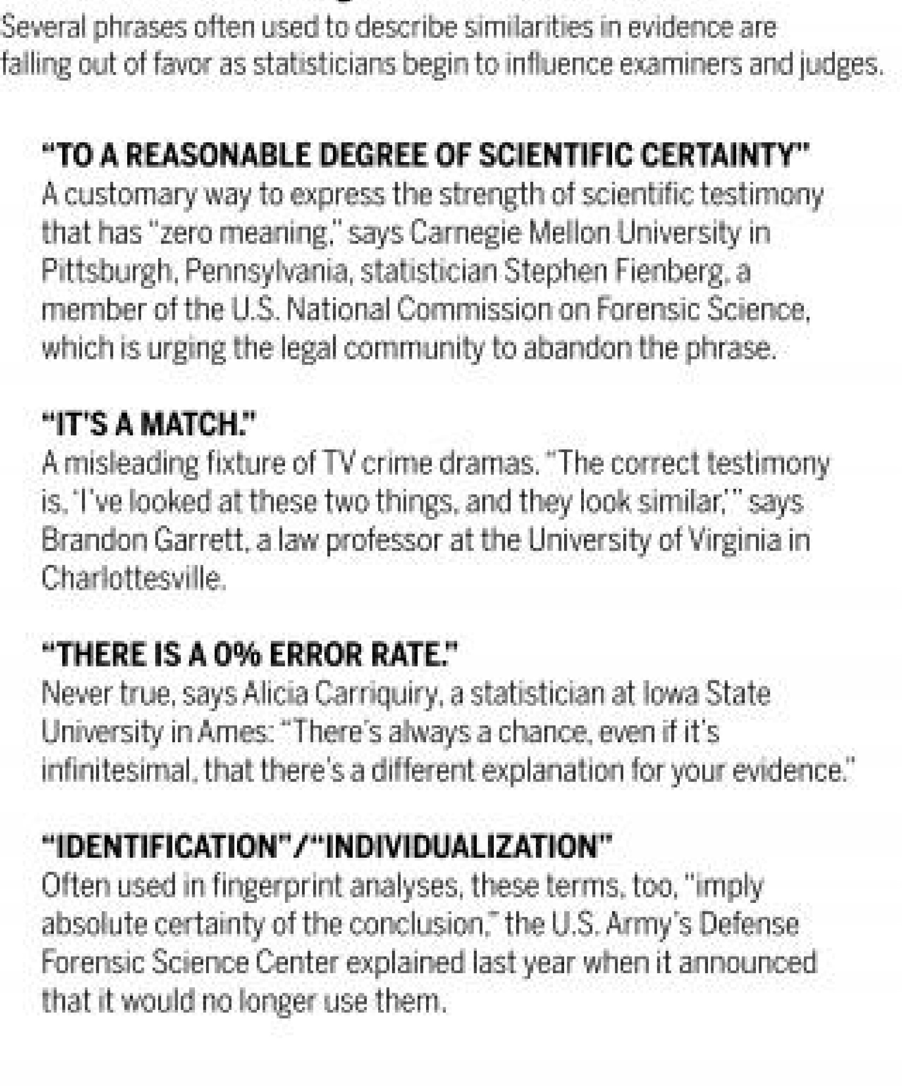

Reversing the legacy of junk science in the courtroom by Kelly Servick, Science Magazine, March 7, 2016.http://www.sciencemag.org/2016/reversing-legacy-junk-science-courtroom
6/3/2016 Proposed Language Regarding Expert Testimony and Lab Reports in Forensic Science | DAG | Department of Justice
https://www.justice.gov/dag/proposedlanguageregardingexperttestimonyandlabreportsforensicscience

PROPOSED LANGUAGE REGARDING EXPERT TESTIMONY AND LAB REPORTS IN FORENSIC SCIENCE

ABOUT

Forensic science is a critical element of the criminal justice system. Forensic scientists examine and analyze evidence from crime scenes and elsewhere to develop objective findings that can absolve an innocent person from suspicion or assist in the investigation and prosecution of perpetrators of crime.

Common forensic science laboratory disciplines include forensic molecular biology (DNA), forensic chemistry, trace evidence examination (hairs and fibers, paints and polymers, glass, soil, etc.), latent fingerprint examination, firearms and toolmarks examination, questioned documents examination, fire and explosives examinations, forensic toxicology, and digital evidence. Some forensic disciplines practiced outside forensic laboratories include forensic pathology, forensic nursing, forensic psychiatry, forensic entomology, and forensic engineering. Practitioners of these disciplines are most often found in medical examiner or coroner offices, in universities, or in private practices.

The Department of Justice forensic laboratories include those at the Bureau of Alcohol, Tobacco, Firearms, and Explosives, the Drug Enforcement Administration, and the Federal Bureau of Investigation. The Department, through the National Institute of Justice, is a sponsor of cuttingedge research and its labs serve as a model for government forensic agencies at the federal, state and local levels. The Department strives to set the global standard for excellence in forensic science, and is always striving to be better.

This website contains information of value to the forensic science community, as well as stakeholders engaged in the criminal justice system with interests in forensic science.

PROPOSED LANGUAGE FOR PUBLIC COMMENT

The comment period for the Proposed Language is available through July 8, 2016.
Public comments may be submitted through www.regulations.gov.

Department of Justice Proposed Uniform Language for Testimony and Reports for the Forensic Toxicology Discipline

Supporting Documentation for Department of Justice Proposed Uniform Language for Testimony and Reports for the Forensic Toxicology Discipline
Department Of Justice Proposed Uniform Language for Testimony and Reports for the Forensic Examination of Serology
Supporting Documentation For Department of Justice Proposed Uniform Language for Testimony and Reports for the Forensic Examination of Serology
Department Of Justice Proposed Uniform Language for Testimony and Reports for the Forensic Latent Print Discipline
Supporting Documentation for Department of Justice Proposed Uniform Language for Testimony and Reports for the Forensic Latent Print Discipline
Department of Justice Proposed Uniform Language for Testimony and Reports for the Forensic Glass Discipline
Supporting Documentation For Department Of Justice Proposed Uniform Language For Testimony And Reports for the Forensic Glass Discipline

Department of Justice Proposed Uniform Language for Testimony and Reports for the Forensic Footwear and Tire Impression Discipline

Supporting Documentation for Department of Justice Proposed Uniform Language For Testimony and Reportsfor the Forensic Footwear and Tire Impression Discipline

Department of Justice Proposed Uniform Language for Testimony and Reports for the Forensic Textile Fiber Discipline

Supporting Documentation For Department of Justice Proposed Uniform Language for Testimony and Reports for the Forensic Textile Fiber Discipline

Department of Justice Proposed Uniform Language for Testimony and Reports for the General Chemistry Discipline

Supporting Documentation for Department of Justice Proposed Uniform Language for Testimony and Reports for the General Chemistry Discipline

Shaken Baby Syndrome: An illustration of continuing research challenging earlier forensic medical conclusions.
History of Shaken Baby Syndrome
Prepared by Kylie Kuhns,
Project for Innocence Intern, 2014-2015.
Shaken baby syndrome, also referred to now as abusive head trauma or non-accidental injury, humbly arose in 1971 as a hypothesis from British pediatric neurosurgeon Dr. Guthkelch. In a review of thirteen cases of infants with subdural hematomas, five had no sign of violence directed at the head. Dr. Guthkelch hypothesized shaking, rather than battering, could have caused these infants’ subdural hematomas. A few years later, Dr. Caffey, an American pediatric radiologist, published two seminal articles on the “whiplash-shaking and jerking of abused infants.” Dr. Caffey explained the medical contradiction that led him to the conclusion of whiplash-shaking infant syndrome. Dr. Caffey examined infants that had brain injuries and no external injuries. Dr. Caffey explained that a whiplash force applied to the infant might cause the injuries to the brain. Dr. Caffey admitted the evidence of his whiplash theory was “manifestly incomplete and largely circumstantial,” but Dr. Caffey’s main goal was to spread nationwide awareness of the potential dangers whiplash shaking may have on an infant. Although not much happened with Dr. Caffey’s whiplash hypothesis for the next couple of decades, by the 1990s his whiplash hypothesis evolved into the dogmatic shaken baby syndrome.
Shaken baby syndrome is a medical hypothesis that doctors use to diagnosis an infant as abused by shaking when the infant presents with a constellation of injuries called the “triad.” The “triad” consists of three injuries: subdural/subarachnoid hemorrhages, retinal hemorrhages, and brain swelling. In the absence of known explanations that cause the “triad,” such as a high-speed vehicle collision or a fall from a multistory building, a doctor could conclude, as a practical matter, the only possible causal mechanism was violent shaking. Doctors hypothesized that this violent shaking was severe, requiring a force equivalent to a high-speed accident or a multistory fall.
Shaken baby syndrome did not only determine the causal mechanism of the “triad” as abusive and traumatic in nature, but the hypothesis also timed the injury. The shaken baby hypothesis (SBS hypothesis) theorized no lag time would exist between the injury and the evident onset of neurological impairment. This was because the shaking would cause the traumatic rupturing of nerve fibers throughout the brain, which would be devastating and result in immediate loss of function. The impossibility of what is now termed a lucid interval allowed doctors to definitively identify the abuser as the last person with the infant before the infant lost consciousness.
The use of the SBS hypothesis gathered significant strength in prosecutions in the 1990s. Based on the “triad” alone, doctors would routinely testify to complete certainty regarding guilt. Not only could the doctors testify to the abusive mechanism, but also to who the perpetrator was that caused the abuse. Over the next couple decades, “triad” only prosecutions proliferated with the help of the shaken baby syndrome hypothesis, which decisively established guilt.
Despite the popularity, there were early warning signs that the SBS hypothesis might be flawed. In 1987, Dr. Duhaime, a young neurosurgeon, and a group of biomechanical engineers attempted to validate the SBS hypothesis by measuring the force of shaking and comparing that force to the accepted head injury thresholds in infants. Dr. Duhaime’s experiments indicated that the force generated by shaking alone was significantly lower than the accepted infant head injury threshold. Furthermore, Dr. Duhaime’s experiments showed that the force of shaking measured only one-fifteenth of the forced generated by an impact.
In 2001, Dr. Plunkett, a forensic pathologist, published an article on shorts falls from playground equipment. Although Dr. Plunkett’s case studies involved children older than the infants usually diagnosed with shaken baby syndrome, the article provided seemingly indisputable proof that the “triad” could result from falls of less than three feet and that lucid intervals were possible. The biomechanical literature continued to shed doubt on the validity of the shaken baby syndrome. For example, a 2002 biomechanical review concluded that a three-foot fall produces forces approximately ten times greater than shaking; that spontaneous rebleeds may explain the onset of symptoms in children with chronic subdural hemorrhage; and that severe shaking would be expected to damage the cervical cord and spine before producing intracranial injuries.
Beyond the biomechanical engineering studies that indicated shaking alone was an insufficient force to cause the triad without also producing injury to the infant’s spine and the reports that accidental falls could produce the triad, in 2001 the SBS hypothesis received yet another challenge, this time to its theory that the triad was caused by traumatic injury. Dr. Geddes authored two studies raising quite a different explanation for the triad. Dr. Geddes and her researchers studied the brains of infants that allegedly died from abuse. In the first study (Geddes I), the researchers found the infants’ brain pathology was predominately hypoxic or ischemic (i.e., due to lack of oxygenated blood supply) rather than traumatic in nature. Furthermore, Geddes I found the subdural bleeding in allegedly abused infants was typically thin and trivial in quantity, which did not match the SBS hypothesis of traumatically torn bridging veins.
In the second study (Geddes II), Dr. Geddes and the researchers described the evidence supporting the traumatic origin for the brain damage in allegedly abused infants as “scanty.” Additionally, Dr. Geddes concluded that the brain pathology found in allegedly abused infants was indistinguishable from the findings in infants that died of natural causes.
The implications of Geddes I and II, although not dispositive, called the SBS hypothesis into question. The SBS hypothesis relied on the “triad” being caused by the traumatic tearing of veins and axons throughout the infants’ brain. However, Geddes I and II raised the possibility that the “triad” in allegedly violent shaking cases may be attributed to hypoxia-ischemia (lack of oxygenated blood supply). Although the triad primarily only had violent shaking as its causal mechanism, hypoxia-ischemia could be caused by a host of medical conditions that affect the flow of oxygenated blood to the infants’ brain. Geddes I and II challenged the idea that the triad could only be caused by violent shaking in the absence of an explanation equivalent to a high-speed vehicle collision or a multistory fall, and left the door open to numerous possibilities that can cause deprivation of oxygenated blood to the brain as plausible non-traumatic explanations.
Geddes I and II also differentiated from the SBS hypothesis on the timing of the injury. The original SBS hypothesis theorized lucid intervals were not possible, which allowed doctors to identify the perpetrator of the abuse as the last person with the infant before collapse. However with hypoxia-ischemia, if the brain damage (i.e., the “triad”) was secondary to the deprivation of oxygenated blood, then the ensuing brain swelling could develop quickly or slowly, over a period of hours or days, with collapse occurring whenever the brain’s basic needs were no longer met by the dwindling supply of oxygenated blood. Therefore with hypoxia-ischemia, the doctors could no longer definitively time when the injuries occurred, which prevented the doctors from conclusively identifying the perpetrator.
The SBS hypothesis relied on reasoning backward from the “triad” of injuries to a diagnosis of trauma or abuse. Again, the SBS hypothesis theorized that if an infant presented with the “triad” and the caregiver could not give an adequate explanation for the injuries, such as a high-speed accident or a multistory fall, the doctors could conclusively determine the infant was abused and that the last person with the child before collapse caused the injuries. Although there are doctors that still believe in the validity of the shaken baby syndrome hypothesis, many of these supporting doctors recognize that there are many alternative causes or “mimics” of the injuries associated with shaken baby syndrome. Some of these “mimics” include accidental falls, infectious diseases, autoimmune conditions, nutritional deficiencies, and birth trauma. With these “mimics” and the theory of hypoxia-ischemia, first articulated in Geddes I and II, even the supporters of the SBS hypothesis cannot determine an infant was abused as conclusively as they did in the previous two decades.
As for the timing of injuries, the original SBS hypothesis theorized that an abused infant could not have a lucid interval because of the traumatic nature of the injuries. However today there is not real dispute that lucid intervals can occur. The debate about lucid intervals instead focuses on the whether a lucid interval occurred in a particular case given the medical findings and symptoms.
The SBS hypothesis has received criticism over the past couple of decades for the lack of evidence-based medicine and studies supporting its theory. Over those same decades, the evidence-based medicine discovering an array of alternative causes, “mimics,” and causal mechanisms has increased. No matter if a doctor today believes in the validity of the SBS hypothesis, that doctor could not testify as adamantly and conclusively as the doctor did back in 2000 that an infant presenting with the triad was abused or shaken, and that the last person with the infant before collapse caused the injuries.

For more information regarding the science and history of shaken baby syndrome, reference Deborah Tuerkheimer’s book Flawed Convictions: “Shaken Baby Syndrome” and the Inertia of Injustice and Keith Findley’s article Shaken Baby Syndrome, Abusive Head Trauma, and Actual Innocence: Getting It Right.

In other instances, the science was not science at all. Hair comparison is the prime example.
Visual Hair Comparison: Junk Science
The Justice Department and FBI have formally acknowledged that nearly every examiner in an elite FBI forensic unit gave flawed testimony in almost all trials in which they offered evidence against criminal defendants over more than a two-decade period before 2000.
Of 28 examiners with the FBI Laboratory’s microscopic hair comparison unit, 26 overstated forensic matches in ways that favored prosecutors in more than 95 percent of the 268 trials reviewed so far, according to the National Association of Criminal Defense Lawyers (NACDL) and the Innocence Project, which are assisting the government with the country’s largest post-conviction review of questioned forensic evidence.
The cases include those of 32 defendants sentenced to death. Of those, 14 have been executed or died in prison, the groups said under an agreement with the government to release results after the review of the first 200 convictions.
The FBI errors alone do not mean there was no other evidence of a convict’s guilt. Defendants and federal and state prosecutors in 46 states and the District are being notified to determine whether there are grounds for appeals. Four defendants were previously exonerated.
The admissions mark a watershed in one of the country’s largest forensic scandals, highlighting the failure of the nation’s courts for decades to keep bogus scientific information from juries, legal analysts said. The question now, they said, is how state authorities and the courts will respond to findings that confirm long-suspected problems with subjective, pattern-based forensic techniques — like hair and bite-mark comparisons — that have contributed to wrongful convictions in more than one-quarter of 329 DNA-exoneration cases since 1989.
In a statement, the FBI and Justice Department vowed to continue to devote resources to address all cases and said they “are committed to ensuring that affected defendants are notified of past errors and that justice is done in every instance. The Department and the FBI are also committed to ensuring the accuracy of future hair analysis testimony, as well as the application of all disciplines of forensic science.”
Peter Neufeld, co-founder of the Innocence Project, commended the FBI and department for the collaboration but said, “The FBI’s three-decade use of microscopic hair analysis to incriminate defendants was a complete disaster.”
“We need an exhaustive investigation that looks at how the FBI, state governments that relied on examiners trained by the FBI and the courts allowed this to happen and why it wasn’t stopped much sooner,” Neufeld said.
Norman L. Reimer, the NACDL’s executive director, said, “Hopefully, this project establishes a precedent so that in future situations it will not take years to remediate the injustice.”
While unnamed federal officials previously acknowledged widespread problems, the FBI until now has withheld comment because findings might not be representative.
Date: April 18, 2015. Byline: Spencer S. Hsu.
http://www.washingtonpost.com/local/crime/fbi-overstated-forensic-hair-matches-in-nearly-all-criminal-trials-for-decades/2015/04/18/39c8d8c6-e515-11e4-b510-962fcfabc310_story.html

Resources
Just Google wrongful convictions: It’s overwhelming. Here are a handful of resources I have found to be informative, accessible, and/or readable.
Websites:
The Cardozo Innocence Project: www.innocenceproject.org
The National Registry of Exonerations: https://www.law.umich.edu/special/exoneration/Pages/about.aspx
Death Penalty Information Center: www.deathpenaltyinfo.org
The Wrong Carlos: thewrongcarlos.net

Books:
Earley, Pete, Circumstancial Evidence: Death, Life, and Justice in a Southern Town, Bantam Books (1996).
Stevenson, Bryan, Just Mercy: A Story of Justice and Redemption, Spiegel & Grau (2014).
Scheck, Barry; Neufeld, Peter; Jim Dwyer, Actual Innocence: Five Days to Execution and Other Dispatches from the Wrongly Convicted, Doubleday (2000).
Garrett, Brandon, Convicting the Innocent: Where Criminal Prosecutions Go Wrong, Harvard University Press (2012).
Strengthening Forensic Science in the United States: A Path Forward. https://www.ncjrs.gov/pdffiles1/nij/grants/228091.pdf

A subdural hemorrhage (SDH) is a collection of blood accumulating in the potential space between the dura and the arachnoid mater of the meninges around the brain. In a little bit simpler terms, the bleed occurs between the brain and the outermost of the three membrane layers that cover the brain. (Three membrane layers starting with the outermost/closet to the skull: dura, arachnoid, and pia mater). The potential sources of SDHs include the bridging veins, small vessles with the dura itself, the vascular membrane of a healing SDH, and a ruptured intracranial aneurysm. A subarachnoid hemorrhage is a bleeding that occurs in the space between the arachnoid membrane and the pia mater surrounding the brain. Note the difference between a hemorrhage and a hematoma: hemorrhage refers to the actual bleeding into the space, whereas hematoma refers to the blood clot that is created to stop the hemorrhage.
A retinal hemorrhage (RH) is a bleeding of the blood vessels in the retina, the membrane in the back of the eye. Some consider severe RHs highly significant in determining whether an injury is accidental or non-accidental. “Severe RHs are generally understood to be diffuse, too numerous to count hemorrhages, extending to the periphery of the retina, usually involving multiple layers of the retina, and sometimes accompanied by retinoschisis with or without folds.” Reinoschisis is a form of RHs that occurs when there is “splitting of the retinal layers with blood accumulating in the intervening space.”

